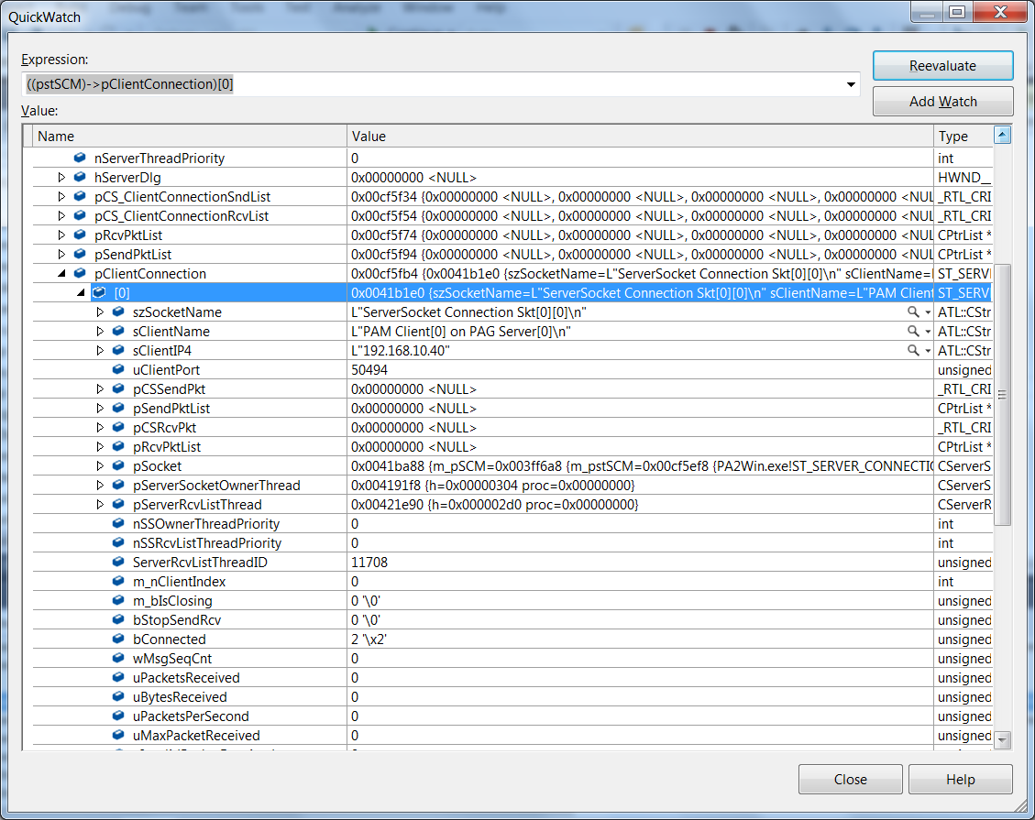

Why does SCM structure have Client Send & Receiver lists a part from the pClientConnection??

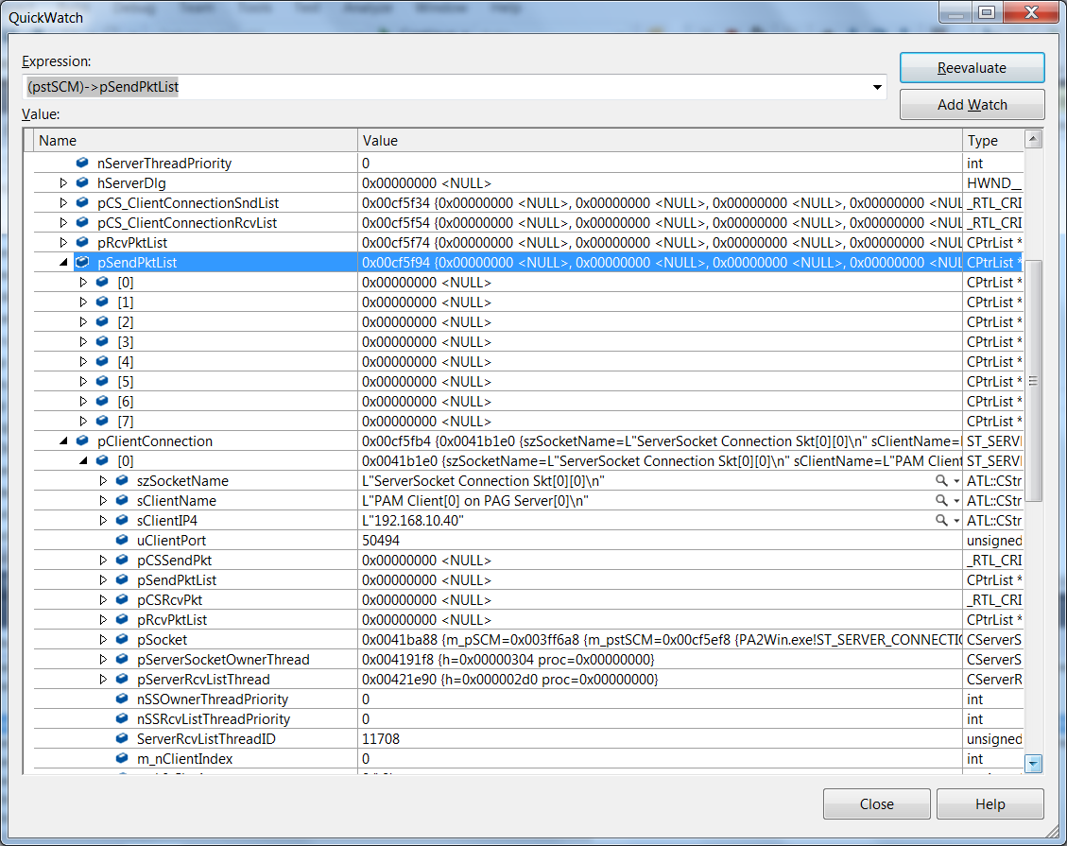

void CPA2WinDlg::DestroySCM( void )

{

int i,j,k;

ST_SERVER_CONNECTION_MANAGEMENT *pstSCM;

CString s;

for (i = 0; i < gnMaxServers; i++)

{

if ( pSCM[i])

{

pstSCM = pSCM[i]->m_pstSCM;

pSCM[i]->StopListenerThread(i); <- triggers a code break

e:\phasedarrayii\phasedarray_ii_tfs\pa2win\pa2win\serverconnectionmanagement.cpp(291) : atlTraceGeneral - ~CServerConnectionManagement Destructor[0] has run

e:\phasedarrayii\phasedarray_ii_tfs\pa2win\pa2win\pa2windlg.cpp(296) : atlTraceGeneral - CPA2WinDlg destructor has run

The thread 0x2820 has exited with code 0 (0x0).

The thread 0x2dbc has exited with code 0 (0x0).

The thread 0x17f8 has exited with code 0 (0x0).

The thread 0x1950 has exited with code 0 (0x0).

The thread 0x2a04 has exited with code 0 (0x0).

Detected memory leaks!

Dumping objects ->

e:\phasedarrayii\phasedarray_ii_tfs\pa2win\pa2win\**serverrcvlistthread**.cpp(78) : {5006} client block at 0x00421E90, subtype c0, **96 bytes** long.

f:\dd\vctools\vc7libs\ship\atlmfc\src\mfc\dumpcont.cpp(23) : atlTraceGeneral - a **CServerRcvListThread** object at $00421E90, 96 bytes long

{4959} normal block at 0x00420C40, **496 bytes long**.

Data: < > CD CD CD CD CD CD CD CD CD CD CD CD CD CD CD CD

{4955} normal block at 0x0041CB70, **16544** bytes long.

Data: < > 88 B0 CD 00 CD CD CD CD CD CD CD CD CD CD CD CD

f:\dd\vctools\vc7libs\ship\atlmfc\src\mfc\strcore.cpp(162) : {4951} normal block at 0x003FD198, 34 bytes long.

Data: < 8 > C0 38 A2 0F 08 00 00 00 08 00 00 00 01 00 00 00

{4950} client block at 0x0041BA88, subtype c0, **4280 bytes long**.

f:\dd\vctools\vc7libs\ship\atlmfc\src\mfc\dumpcont.cpp(23) : atlTraceGeneral - a **CAsyncSocket** object at $0041BA88, **4280** bytes long

{4934} client block at 0x004191F8, subtype c0, 108 bytes long.

f:\dd\vctools\vc7libs\ship\atlmfc\src\mfc\dumpcont.cpp(23) : atlTraceGeneral - a **CServerSocketOwnerThread** object at $004191F8, 108 bytes long

f:\dd\vctools\vc7libs\ship\atlmfc\src\mfc\strcore.cpp(162) : {4902} normal block at 0x003E6580, 44 bytes long.

Data: < 8 > C0 38 A2 0F 0D 00 00 00 0D 00 00 00 01 00 00 00

Object dump complete.

The program '[10976] PA2Win.exe' has exited with code 0 (0x0).